|  |  |
| --- | --- |
| **Title:** | **Up Above** |
| **Source:** | Smith, D. (2011). *Musicianship & aural training for the secondary school: Level 1*. Deborah Smith Music. |
| **Origin:** | Words and music by Deborah Smith - used with permission <https://dsmusic.com.au/> |

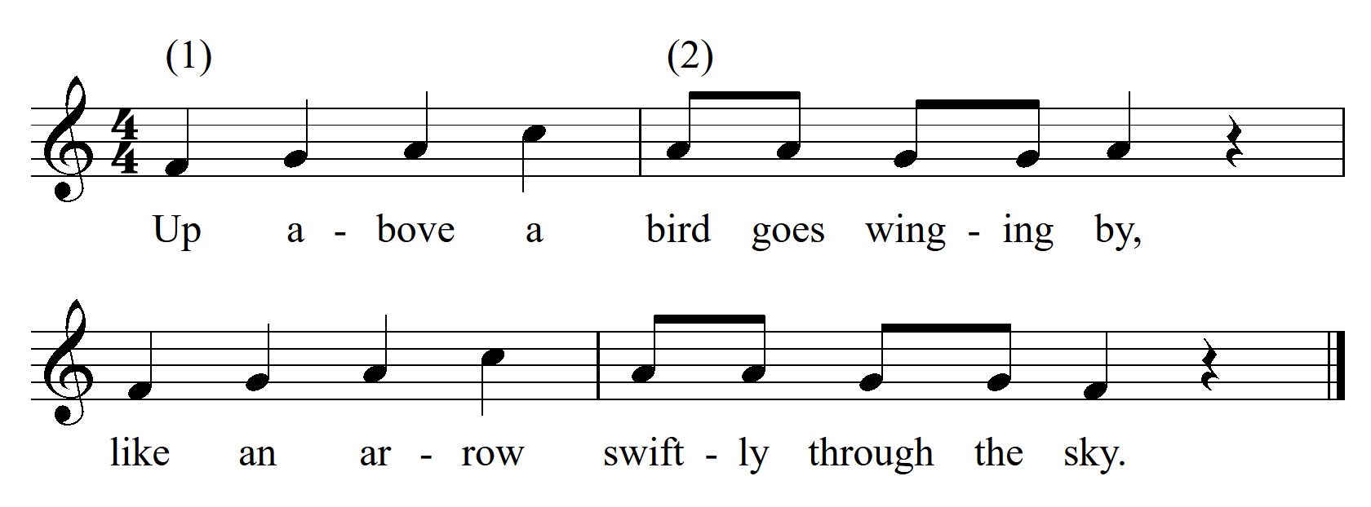

|  |  |  |  |
| --- | --- | --- | --- |
| **Tone Set:** |  | **Scale Type:** |  |
| **Form:** |  | **CSP:** |  |
| **Type of Song/Game:** |  | | |
| **Rhythmic Element(s) Emphasised:** |  | **Metre:** |  |
| **Melodic Element(s) Emphasised:** |  | | |
| **Appropriate Year Level:** |  | | |
| **Teaching Purpose(s):** |  | | |