Title: | Pourquoi (“Oh” said the Blackbird)
Source: | Erdei, P., & Komlos, K. (1988)  150 American folksongs to sing, read and play. Boosey & Hawkes.
Origin: | USA

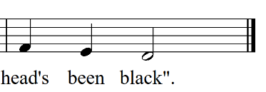
Source version of final bar:

Tone Set: |  | Scale Type:
Form: |  | CSP:
Type of Song/Game:
Rhythmic Element(s) Emphasised: |  | Metre:
Melodic Element(s) Emphasised:
Appropriate Year Level:
Teaching Purpose(s):

