Title of Work: | O Nightingale
Excerpt Title:
Composer: | Philip James (1890-1975) | Date:

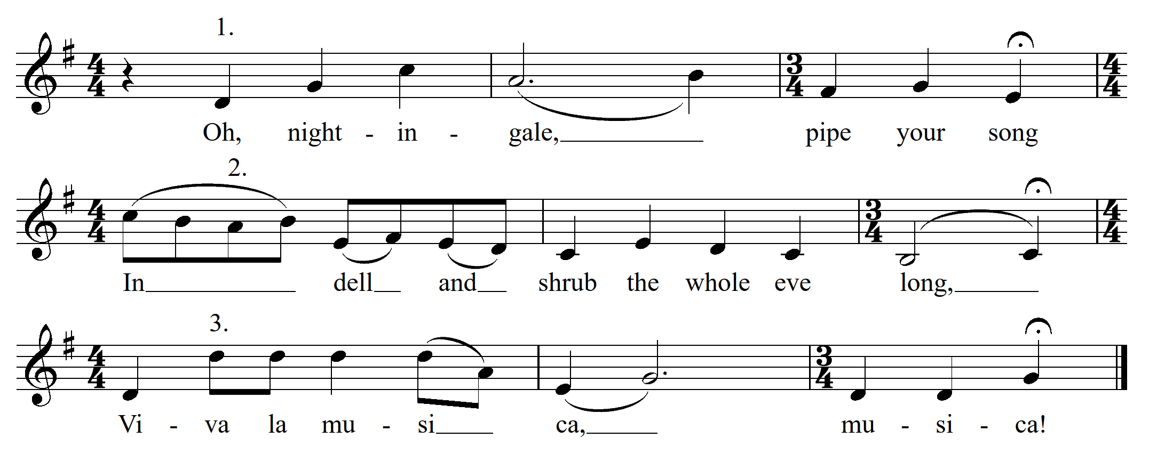

Genre and/or Style:
Stylistic and/or Compositional Devices Emphasised:
Duration Emphasised (rhythm, metre, tempo):
Pitch Emphasised (melody, tonality, harmony):
Structure and Form Emphasised:
Texture and Timbre Emphasised:
Appropriate Year Level:
Teaching Purpose(s):

