Title: | Come Follow Me
Source: | Vajda, C. (1974).The Kodály way to music: The method adapted for British schools (Vol. 2). Boosey & Hawkes.
Origin:

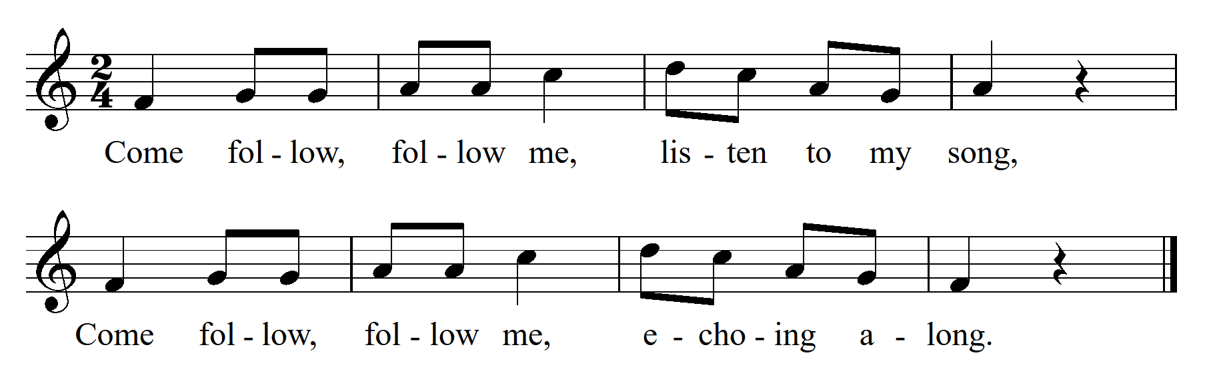

Tone Set: |  | Scale Type:
Form: |  | CSP:
Type of Song/Game:
Rhythmic Element(s) Emphasised: |  | Metre:
Melodic Element(s) Emphasised:
Appropriate Year Level:
Teaching Purpose(s):

