Title: | Chatter with the Angels
Source: | Kersey, R. (1972), Just Five, A Collection of Pentatonic Songs.  Belwin-Mills Publishing Corp.  Words (as “I Hope I’ll Join the Band”) collected from  Work, K. (1915) Folk Song of the American Negro.  Press of the Fisk University.
Origin: | USA

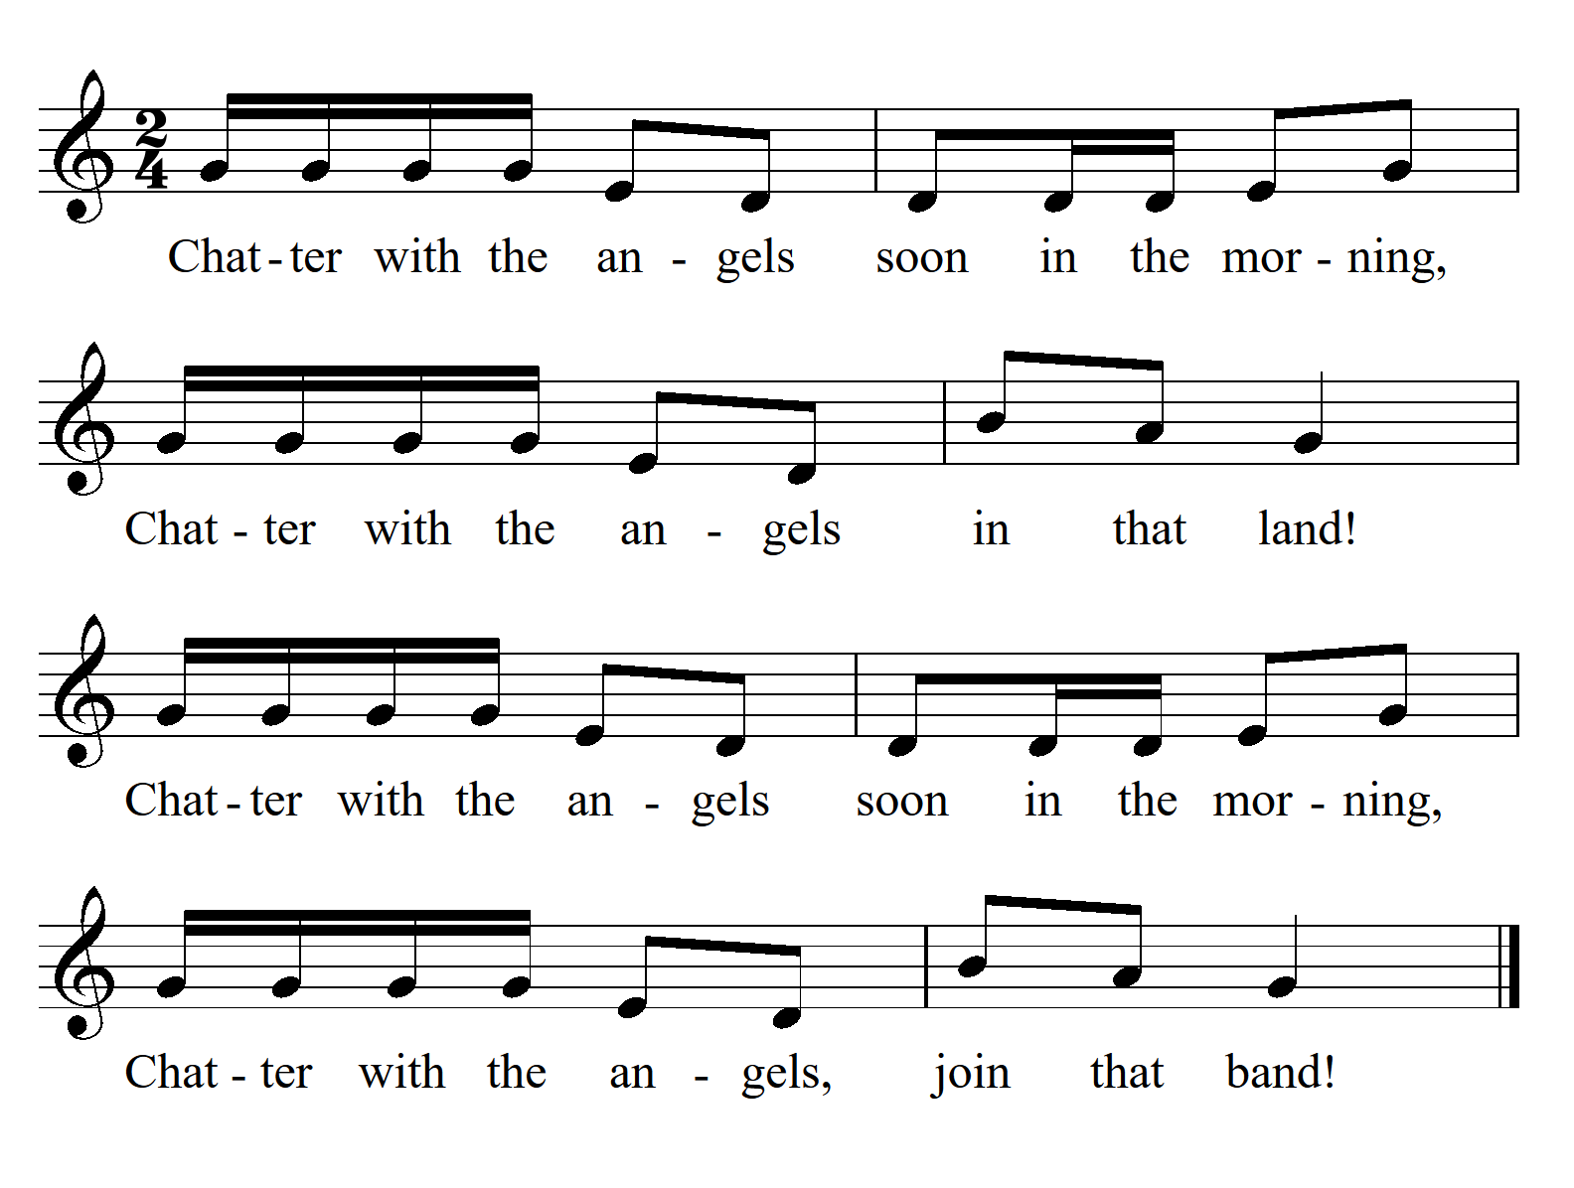

Tone Set: |  | Scale Type:
Form: |  | CSP:
Type of Song/Game:
Rhythmic Element(s) Emphasised: |  | Metre:
Melodic Element(s) Emphasised:
Appropriate Year Level:
Teaching Purpose(s):

