|  |  |
| --- | --- |
| **Title:** | **Blow the Wind Southerly** |
| **Source:** | Sur, W., Nye, R., Fisher, W., & Tolbert, M. (1962) *This is Music Vol. V*  Allyn & Bacon |
| **Origin:** | English Folksong |

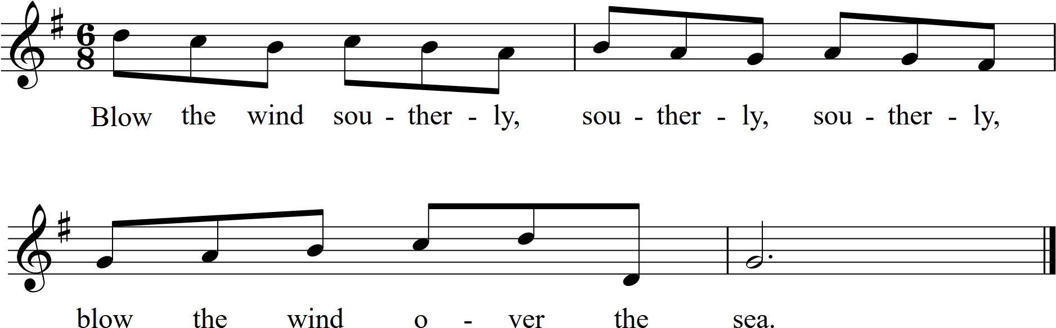

|  |  |  |  |
| --- | --- | --- | --- |
| **Tone Set:** |  | **Scale Type:** |  |
| **Form:** |  | **CSP:** |  |
| **Type of Song/Game:** |  | | |
| **Rhythmic Element(s) Emphasised:** |  | **Metre:** |  |
| **Melodic Element(s) Emphasised:** |  | | |
| **Appropriate Year Level:** |  | | |
| **Teaching Purpose(s):** |  | | |