Title: | The Birch Tree
Source: | Bolkovac, E., & Johnson, J. (1996). 150 rounds for singing and teaching. Boosey & Hawkes.
Origin: | Traditional Russian Folksong known as “Beriozka”, “Berezka” or “Beroza”

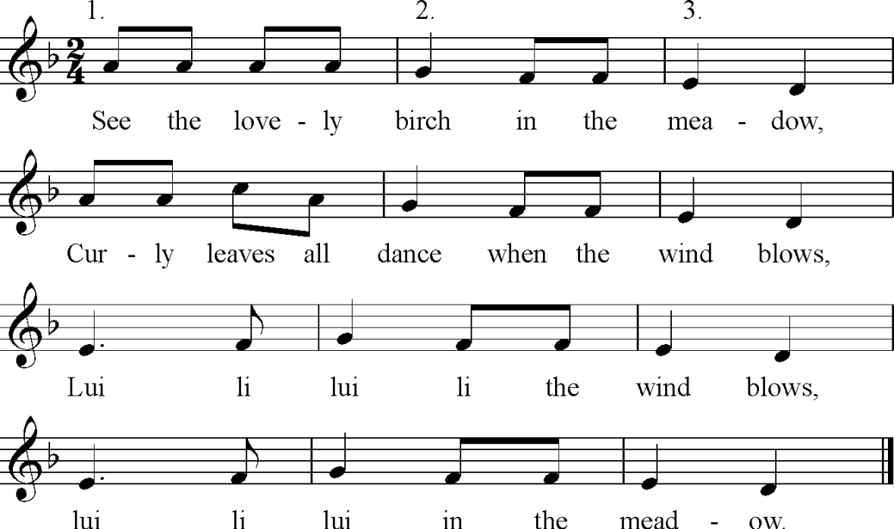

Tone Set: |  | Scale Type:
Form: |  | CSP:
Type of Song/Game:
Rhythmic Element(s) Emphasised: |  | Metre:
Melodic Element(s) Emphasised:
Appropriate Year Level:
Teaching Purpose(s):

