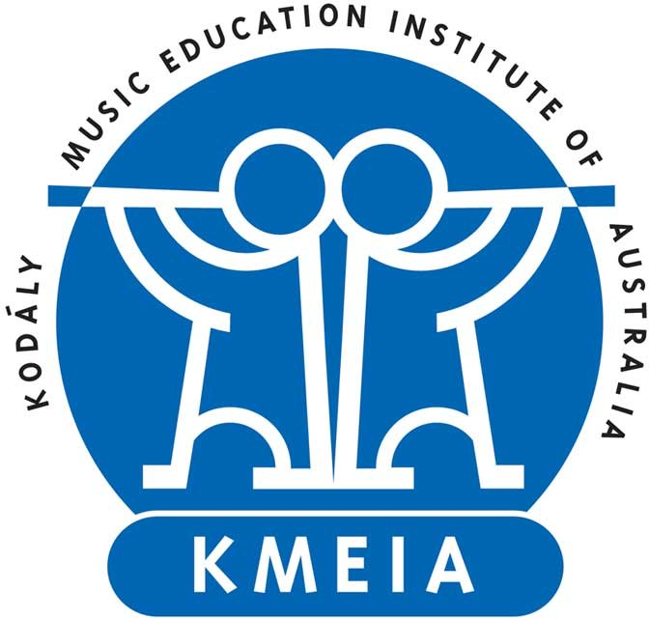
2022 Awards for Excellence in Australian
Kodály-inspired Music Education

The Awards for Excellence in Australian Kodály-inspired Music Education seek to recognise members of our community who have demonstrated an outstanding contribution and impact benefitting Australian Kodály-inspired music education.

Award Presentation
The awards are presented biennially at the Kodály Australia Conference. Kodály Australia reserves the right to not present an award if there are no suitable nominations. It is desirable that the recipient of an award is able to attend the presentation at the biennial Kodály Australia Conference.

Eligibility
The award nominator and nominee must be Australian citizens or permanent residents 18 years or older and have been financial members of Kodály Australia for at least the past two years. The nominee must have not previously received the category award.

Award Categories
Recipients will be awarded for each of the following categories for work completed within the past two years:

- Innovation – for outstanding innovation in Australian Kodály-inspired music education
- Research – for outstanding research output (including traditional and creative works) investigating Australian Kodály-inspired music education
- Australian Aboriginal and Torres Strait Islander Peoples’ Perspectives – for an outstanding example of including Australian Aboriginal and Torres Strait Islander Peoples’ perspectives in Australian Kodaly-inspired music education
- Early Career Teacher (within 5 years of completing initial teacher education) – for an outstanding example of early-career teaching practice informed by Australian Kodály-inspired music education
- Mentoring – for an outstanding example of mentoring in Australian Kodály-inspired music education

Selection Criteria
Each application will be assessed according to the following criteria relevant to the nominated category:

- Demonstrated personal teaching and musical excellence
- Demonstrated contribution of work to Australian Kodály-inspired music education and/or the Kodály Australia community
- Demonstrated impact of work on Australian Kodály-inspired music education and/or the Kodály Australia community
- Potential model for others

Important Dates
1 January even year Nominations open
31 March even year Closing date for nominations
May even year Recipient of the award informed and public announcement through online communication
Kodály Australia Conference even year Presentation of the award

Submission
- Digital nominations will only be accepted.
- Please include a high-quality digital professional photograph and a 200-word biography with your application.
- Please email your completed documentation to the Scholarships and Awards Committee Convenor (awards@kodaly.org.au).
- Incomplete nominations will not be considered.

2022 Awards for Excellence in Australian Kodály-inspired Music Education

Nomination Category
Category | Click or tap here to enter text.

Personal Details of Nominator (author of this form)
Title | Click or tap here to enter text.
Surname | Click or tap here to enter text.
Given Name | Click or tap here to enter text.
Email | Click or tap here to enter text.
Residential Address | Click or tap here to enter text.
Home Phone | Click or tap here to enter text.
Work Phone | Click or tap here to enter text.
Mobile | Click or tap here to enter text.
Residency Status | ☐ I am an Australian citizen or permanent resident

Personal Details of the Nominee (potential award recipient)
☐ Same as above
Title | Click or tap here to enter text.
Surname | Click or tap here to enter text.
Given Name | Click or tap here to enter text.
Email | Click or tap here to enter text.
Residential Address | Click or tap here to enter text.
Home Phone | Click or tap here to enter text.
Work Phone | Click or tap here to enter text.
Mobile | Click or tap here to enter text.
Residency Status | ☐ I am an Australian citizen or permanent resident

Employment
Current Position | Click or tap here to enter text.
Current Employer | Click or tap here to enter text.

Education
Qualification (from most recent) | Institution | Year Completed
Click or tap here to enter text. | Click or tap here to enter text. | Click or tap here to enter text.
Click or tap here to enter text. | Click or tap here to enter text. | Click or tap here to enter text.
Click or tap here to enter text. | Click or tap here to enter text. | Click or tap here to enter text.
Click or tap here to enter text. | Click or tap here to enter text. | Click or tap here to enter text.

Reasons for Nomination
Please provide extensive detail outlining your reasons for nomination in relation to the nominated category and selection criteria. (approx. 500 words)

Click or tap here to enter text.

Declaration by Nominator (author of this form)
☐ By ticking this box, I agree to the following:
- I state that all information in this application is true and correct.
- I accept that Kodály Australia has the right to reject a nomination or retract the Award on the basis of false or misleading information forming any part of my nomination.
- I agree my Reasons for Nomination may be published by Kodály Australia.

Nominator’s full name: Click or tap here to enter text.

Date: Click or tap to enter a date.

Declaration by Nominee (potential award recipient)
☐ By ticking this box, I agree to the following:
- I accept the nomination for this award.
- I have included:
  - 1 high-quality digital professional photograph
  - 200-word biography with a focus on Kodály-inspired music education
- I state that all information in this application is true and correct.
- I accept that Kodály Australia has the right to reject a nomination or retract the Award on the basis of false or misleading information forming any part of this nomination.
- I agree my name, state of residence, biography and the Reasons for Nomination may be published by Kodály Australia.

Nominator’s full name: Click or tap here to enter text.

Date: Click or tap to enter a date.

