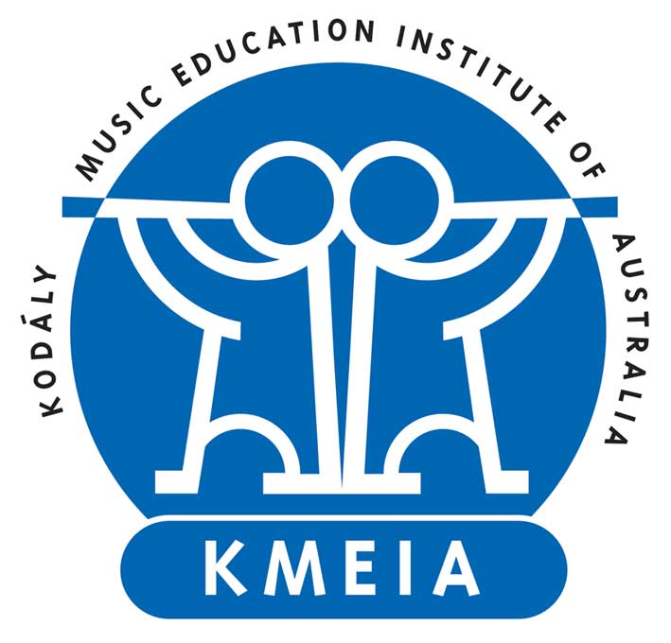
Kodály Australia
Australian Kodály Scholarship 2020

The Australian Kodály Scholarship (AKS) provides financial assistance to a member(s) of Kodály Australia (KMEIA Inc) to develop an Australian Kodály-inspired pedagogical resource which will be made available for free on the national website.

Award Presentation
The scholarship is awarded biennially at the Kodály Australia National Conference. A presentation will be made outlining the project details of the successful recipient. The recipient of the award is encouraged, but not required to attend the presentation at the biennial Kodály Australia National Conference. Kodály Australia reserves the right to not award the scholarship if there are no suitable applicants.

Value
The value of the scholarship is $3000, paid in Australian dollars by means of electronic bank transfer into an Australian bank account. The funds can only be used for purchases within Australia. Receipts are required to be kept.

Eligibility
- An Australian citizen 18 years or older.
- Current financial member of Kodály Australia.
- Have not previously received the scholarship.

Length of Project
The project must be completed and funds spent within 18 months from the date of the announcement at the Kodály Australia National Conference. The report must be provided no later than 2 months following the conclusion of the project.

Publications and/or Resources
All publications and/or resources produced as a result of this scholarship must include the following acknowledgement: “This publication/resource was made possible through the generous support of the Australian Kodály Scholarship.”

Report
The recipient of the Australian Kodály Scholarship is required to present a detailed electronic report to the Kodály Australia National Council (approximately 2000 words) at the conclusion of their project. The report will outline how the funds were spent (including receipts), a description of the activities undertaken, outcomes of the project and potential benefits to the Australian community. The author will retain copyright of the report. Kodály Australia will publish the report online and distribute it to members.

Presentation
Recipients are required to present a workshop introducing Kodály Australia members to the resource either through their local branch, an AKC course provider or national conference. It is the responsibility of the recipient to organise/apply to present this presentation within 2 years after completing the resource. A copy of the presentation abstract and digital video of the presentation must be provided to National Council.

Selection Criteria
Each application will be assessed according to the following criteria:
- Project feasibility
- Applicant expertise and experience
- Expected benefit to the advancement of Australian Kodály movement
- Expected benefit to the Australian community
- Potential model for others

Important Dates
1 January even year Applications open
31 March even year Closing date for nominations
May even year Recipient of the award informed and public announcement through online communication
National Conference even year Public presentation of the award

Submission
- Applications will only be accepted electronically.
- Please email your completed documentation to the Kodály Australia National Administrator (national.administrator@kodaly.org.au).
- Incomplete applications will not be considered.
- In the case of a collaborative project, the leader of the project should apply.
Australian Kodály Scholarship
2020 Application Form

Personal Details
Title | Click here to enter text.
Surname | Click here to enter text.
Given Name | Click here to enter text.
Date of Birth | Click here to enter a date.
Email | Click here to enter text.
Residential Address | Click here to enter text.
Home Phone | Click here to enter text.
Work Phone | Click here to enter text.
Mobile | Click here to enter text.
Nationality | Click here to enter text.
Have you previously applied? | Choose an item.

Employment
Current Position | Click here to enter text.
Current Employer | Click here to enter text.
Date Commenced | Click here to enter a date.
Previous Employer | Click here to enter text.
Position Held | Click here to enter text.
Dates | From Click here to enter a date. to Click here to enter a date.

Education
Qualification (from most recent) | Institution | Year Completed
Click here to enter text. | Click here to enter text. | Click here to enter text.
Click here to enter text. | Click here to enter text. | Click here to enter text.
Click here to enter text. | Click here to enter text. | Click here to enter text.
Click here to enter text. | Click here to enter text. | Click here to enter text.

Are you currently enrolled at any tertiary institution? Choose an item.
If, yes, what degree(s) and expected completion date:
Click here to enter text.

Are your current studies related to your project? Explain:
Click here to enter text.

Scholarships and Grants
Please list details of previous awarded scholarships and grants
Scholarship name | Institute | Date | Value
Click here to enter text. | Click here to enter text. | Click here to enter text. | Click here to enter text.
Click here to enter text. | Click here to enter text. | Click here to enter text. | Click here to enter text.
Click here to enter text. | Click here to enter text. | Click here to enter text. | Click here to enter text.

Proposed Resource Overview
Title (approx. 10-15 words)
Click here to enter text.

Aim (approx. 20 words)
Click here to enter text.

Description (approx. 200 words)
Click here to enter text.

Project leader biography (approx. 100 words)
Click here to enter text.

Proposed Itinerary
City, State, Country | Name of Institution / Organisation | Purpose | From | To
Click here to enter text. | Click here to enter text. | Click here to enter text. | Click here to enter text. | Click here to enter text.
Click here to enter text. | Click here to enter text. | Click here to enter text. | Click here to enter text. | Click here to enter text.
Click here to enter text. | Click here to enter text. | Click here to enter text. | Click here to enter text. | Click here to enter text.
Click here to enter text. | Click here to enter text. | Click here to enter text. | Click here to enter text. | Click here to enter text.
Click here to enter text. | Click here to enter text. | Click here to enter text. | Click here to enter text. | Click here to enter text.

Proposed Budget
Indicate below what expenses will be supported by the scholarship and what costs will be covered by personal funding.
Expense Type | Scholarship Fund | Personal Funding Available
Click here to enter text. | Click here to enter text. | Click here to enter text.
Click here to enter text. | Click here to enter text. | Click here to enter text.
Click here to enter text. | Click here to enter text. | Click here to enter text.
Click here to enter text. | Click here to enter text. | Click here to enter text.
Click here to enter text. | Click here to enter text. | Click here to enter text.
Totals | Click here to enter text. | Click here to enter text.
Total Budget | Click here to enter text.

Reasons for Application
What experience do you have to undertake this project? (approx. 200 words)
Click here to enter text.

What new knowledge do you hope to gain and other than your AKS Report how will you disseminate the findings to the Australian community? (approx. 150 words)
Click here to enter text.

How will your project benefit the Australian Kodály movement? (approx. 200 words)
Click here to enter text.

How will your project benefit the Australian community? (approx. 200 words)
Click here to enter text.

Declaration

All applications must agree to the following (please read and check each box):

☐ I state that all information in this application is true and correct.

☐ I have included:
- 1 High quality digital professional photograph
- 1 Professional reference
- 1 Academic reference
- Supporting documentation for costs
- Proof of acceptance in course (if applicable)

☐ I understand that my referees may be contacted by Kodály Australia as part of the selection process.

☐ I accept that Kodály Australia has the right to reject an application or retract the Scholarship on the basis of false or misleading information forming any part of my AKS application.

☐ If I am the recipient of the Scholarship and become unable to complete the project as outlined, I agree to fully repay the Scholarship funds plus loss of interest.

☐ If I am the recipient of the Scholarship, I agree that my full name, city of residence, submitted photograph, biography and details of my project will be publicly announced and published by Kodály Australia.

☐ If I am the recipient of the Scholarship, I will provide a report to Kodály Australia for publication as outlined on page 1 of this application.

☐ Any publications and/or resources produced as a result of this scholarship will include the following acknowledgement: “This publication/resource was made possible through the generous support of the Australian Kodály Scholarship.”

Applicant’s full name: Click here to enter text.
Date: Click here to enter a date.

