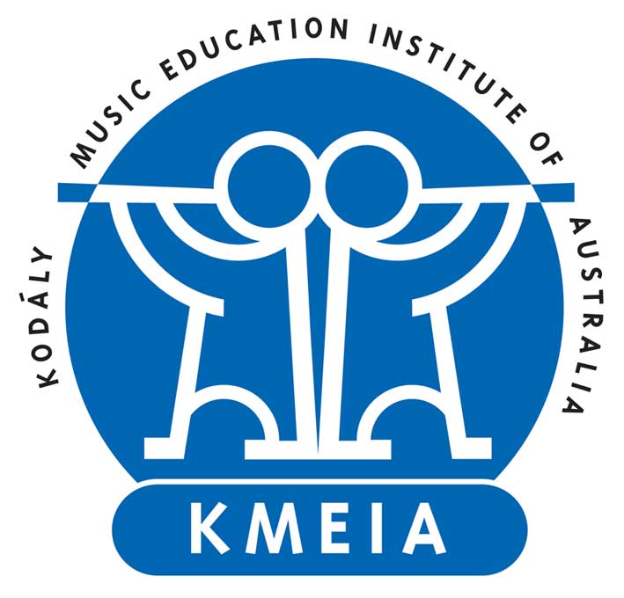
Kodály Music Education Institute of Australia
Australian Kodály Certificate
Lecturer Mentoring Application Form

Prospective lecturers for the Australian Kodály Award and Certificate are required to seek Mentorship from an Accredited Lecturer(s) before applying for accreditation. The program consists of mentoring in a specialisation level consisting of Pedagogy, Practicum and Materials and 1 elected module. Mentees will also complete observation in the 2 remaining modules. The purpose of Mentorship is to gain a deeper insight of the curriculum, logistical operations and participant needs in an Australian Kodály Award and Certificate course.

Criteria
All applicants are measured against the following criteria. At least five of the seven must be successfully demonstrated.

The applicant demonstrates:
- Extensive formal education within the Kodály framework
- A sophisticated understanding of Kodály philosophy
- Recognised success teaching children and adults in contexts such as Universities, community classes and workshop presentations
- An international perspective on Kodály philosophy and practice such as participation in IKS Symposiums
- Knowledge and experience of the Australian Kodály Award/Certificate Curriculum
- Outstanding communication skills
- An ability to collaborate, work with and mentor colleagues

Applicants are further judged on the following criteria for each specific module and level.

The applicant demonstrates:
- A high level of musicianship applicable to the specific module specialisation and level
- A comprehensive understanding of Kodály inspired methodology and practice applicable to the specific module specialisation and level
- Recognised success in practice over an extended period of time relevant to the specific module specialisation and level

Further Information
Please carefully read the Lecturer Accreditation Policy and Procedures including Mentoring document available online before completing this application form.

Personal Details
Title | Click or tap here to enter text.
Surname | Click or tap here to enter text.
Given Name | Click or tap here to enter text.
Email | Click or tap here to enter text.
Residential Address | Click or tap here to enter text.
Home Phone | Click or tap here to enter text.
Work Phone | Click or tap here to enter text.
Mobile | Click or tap here to enter text.
Nationality | Click or tap here to enter text.
Have you previously applied? | Choose an item.

Mentorship Proposal
Course Provider | Click or tap here to enter text.
Mentor(s) | Click or tap here to enter text.
Specialisation level consisting of Pedagogy, Practicum and Materials  (e.g., Primary Level 1) | Click or tap here to enter text.
1 Conducting, Musicianship or Choir Module (e.g., Musicianship Level 3) | Click or tap here to enter text.
2 other modules for observation | Click or tap here to enter text.
Have you discussed your application with your proposed mentor(s)? | Choose an item.

Response to Criteria
Please provide a direct response to each criterion below.

1. Extensive formal education within the Kodály framework (150 words max).
Click or tap here to enter text.

2. A sophisticated understanding of Kodály philosophy (150 words max).
Click or tap here to enter text.

3. Recognised success teaching children and adults in contexts such as Universities, community classes and workshop presentations (150 words max).
Click or tap here to enter text.

4. An international perspective on Kodály philosophy and practice such as participation in IKS Symposiums (150 words max).
Click or tap here to enter text.

5. Knowledge and experience of the Australian Kodály Award/Certificate Curriculum (150 words max).
Click or tap here to enter text.

6. Outstanding communication skills (150 words max).
Click or tap here to enter text.

7. An ability to collaborate, work with and mentor colleagues (150 words max).
Click or tap here to enter text.

Please provide a direct response to each criterion of your nominated modules below.

Pedagogy Practicum and Materials Module
1. A high level of musicianship applicable to the specific module specialisation and level (150 words max).
Click or tap here to enter text.

2. A comprehensive understanding of Kodály inspired methodology and practice applicable to the specific module specialisation and level (150 words max).
Click or tap here to enter text.

3. Recognised success in practice over an extended period of time relevant to the specific module specialisation and level (150 words max).
Click or tap here to enter text.

Conducting, Musicianship or Choir Module
1. A high level of musicianship applicable to the specific module specialisation and level (150 words max).
Click or tap here to enter text.

2. A comprehensive understanding of Kodály inspired methodology and practice applicable to the specific module specialisation and level (150 words max).
Click or tap here to enter text.

3. Recognised success in practice over an extended period of time relevant to the specific module specialisation and level (150 words max).
Click or tap here to enter text.

Supporting Documentation
Please attach the following documentation to support your application:

- Curriculum vitae
- Evidence to support your response to the selection criteria (e.g., transcripts, planning documents, teaching demonstration videos, participant testimonials)
- A reference from an AKC Course Provider addressing the selection criteria is encouraged

These documents may later be used again in the Lecturer Accreditation application process.

Privacy
Kodály Australia’s Privacy Policy is available online. http://www.kodaly.org.au/privacy/

Declaration
By signing below, I agree the information contained in this application to be true and accurate. I acknowledge that I have read and understand the Lecturer Accreditation including Mentoring Policy and Procedures document. The Education Committee may seek to clarify or request further information if necessary.

Signed: Click or tap here to enter text.

Date: Click or tap to enter a date.

Submission
Send your digital application and supporting documents to:

Education Committee Convenor
Kodály Australia National Council
education@kodaly.org.au

